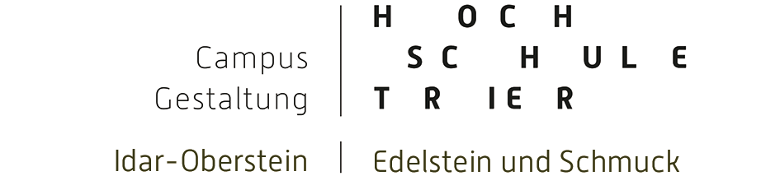 | ECTS STUDENT LEARNING AGREEMENT
 | ACADEMIC YEAR
 | FIELD OF STUDY | Gemstone and Jewellery

Name of student
Sending institution
Country

DETAILS OF THE PROPOSED STUDY PROGRAMME ABROAD/LEARNING AGREEMENT

Receiving institution | Hochschule Trier (D Trier 02)
Country | Germany

Course unit code | Course unit title | Number of ECTS credits
 | Gemstone | 8
 | Jewellery | 8
 | Art | 8
 | Presentation | 3
 | Campus Credits | 3

Student’s signature | Date

SENDING INSTITUTION
We confirm that the proposed programme of study/learning agreement is approved.
Departmental coordinator’s signature | Institutional coordinator’s signature
Date | Date

HOST INSTITUTION
We confirm that the proposed programme of study/learning agreement is approved.
Departmental coordinator’s signature | Institutional coordinator’s signature
Date | Date

Name of student
Sending institution

CHANGES TO ORIGINAL PROPOSED STUDY PROGRAMME/LEARNING AGREEMENT
(to be filled in ONLY if appropriate)

Course unit code (if any) and page no. of the information package | Course unit title (as indicated in the information package) | Deleted  course  unit | Added  course  unit | Number of  ECTS credits
 |  | □ | □
 |  | □ | □
 |  | □ | □
 |  | □ | □
 |  | □ | □
 |  | □ | □
 |  | □ | □
 |  | □ | □
 |  | □ | □
 |  | □ | □
 |  | □ | □

Student’s signature | Date

SENDING INSTITUTION
We confirm that the above-listed changes to the initially agreed programme of study/learning agreement are approved.
Departmental coordinator’s signature | Institutional coordinator’s signature
Date | Date

RECEIVING INSTITUTION
We confirm that the above-listed changes to the initially agreed programme of study/learning agreement are approved.
Departmental coordinator’s signature | Institutional coordinator’s signature
Date | Date

